EVENT MANAGEMENT and ORGANIZING USING MERN STACK
Megala P ¹, Binusakthi R², Dharshan P M³, Sundaramalingam K⁴, Vetrivel J⁵

¹Computer and Communication Department, Sri Eshwar College of Engineering
Coimbatore, India

¹ megala.p@sece.ac.in
² binusakthi.cce2020@sece.ac.in
³ dharshanp.v2020cce@sece.ac.in
⁴ sundaramagalingam.k2020cce@sece.ac.in
⁵ vetrivel.j2020cce@sece.ac.in

Abstract— The company provides a wide range of services, such as choosing a wedding mahal, groom and bride beauty salon services, magnificent decorations, opulent automobiles for guests, cozy hotel rooms, and great catering. This management event company strives to bring clients' thoughts to life and make sure that every part of their big day is done beautifully. They do this by paying close attention to every last detail and making a commitment to offering an amazing experience. Prospective customers can learn more about the company's services through this content, which also includes pictures and contact information for more information and individualized support.

Keywords—Mongo DB, Express, React JS, Node JS, Postman, Mongo DB Atlas.

- Introduction

A seamless fusion of cutting-edge tools and effective coordination are needed to orchestrate successful events in today's quickly changing technology environment. A potent approach to building feature-rich, scalable, and real-time event management systems is the MERN Stack, which combines MongoDB, Express.js, React.js, and Node.js.[1]

Events require careful preparation and perfect execution, whether they are business conferences, trade exhibits, social gatherings, or entertainment extravaganza. In the past, managing registrations, ticketing, attendee engagement, feedback gathering, and real-time updates has presented many difficulties for event organizers. But the introduction of the MERN Stack has completely changed this sector, bringing up new vistas of opportunity and altering the way events are organized.
We will examine the key elements of the MERN Stack and how they work together to produce an end-to-end event management platform throughout this paper presentation. We will begin with MongoDB, a scalable and adaptable NoSQL database, to comprehend how effectively it stores and retrieves event-related data. Next, we'll explore the Express.js web application framework and explore how it helped us build a reliable backend for our event management system. [13,14,15]

React.js, a dynamic JavaScript package renowned for creating interactive user interfaces, will provide life to the front-end of our system. In this article, we'll examine how
React.js makes it simple to design enticing event registration forms, event listings, and attendee dashboards, taking the user experience to new heights. [2,5,6,9]

A server-side JavaScript runtime called Node.js will be crucial in providing real-time updates and seamless communication between the client and server, complementing the front-end. We will discuss the advantages of leveraging Web Sockets and event-driven architecture in our application to deliver real-time updates and notifications to participants and event organizers. [11,12]

Additionally, we will stress the value of responsive design to make sure that our event management software is usable on a variety of platforms, including desktop computers and smartphones. By doing this, we give everyone participating in the event lifecycle a welcoming and interesting experience.

As this paper progresses, we'll also talk about how important security, data privacy, and scalability are. We can put in place strong security measures to protect sensitive attendee data and financial transactions by utilizing the capability of the MERN Stack.

- Motivation

Exploring the field of "Event Management and Organization with MERN Stack" was spurred by a strong desire to transform how events are planned and experienced. In a world where technology permeates every part of our lives, it is crucial to harness its potential to improve attendee experiences and streamline event management procedures.

The human labor-intensive processes, disjointed data management, and restricted real-time communication that are frequently included in traditional event planning systems. These inefficiencies can result in lost opportunities, disgruntled guests, and a decrease in the success of the event. With its integrated components and full-stack capabilities, the MERN Stack offers a strong solution to deal with these issues and change the event management industry.
Methods

1) Review of the Literature: A complete analysis of the published books, journal articles, research studies, and internet databases on event management, MERN Stack, and pertinent technologies was carried out. This stage gave a strong foundation, insights into how event planning is currently going, and possible advantages of adopting the MERN Stack.

2) Technology Familiarization: A thorough examination of their documentation, tutorials, and best practices was conducted in order to comprehend the different elements of the MERN Stack (MongoDB, Express.js, React.js, and Node.js) and their respective roles in web development. This made it possible to clearly comprehend their capabilities and how to use them for event management.

3) Use Case Analysis: To determine how the MERN Stack could be used for various facets of event management, a number of use cases and scenarios were established. These use cases included data analytics, attendee engagement, real-time updates, feedback gathering, and event registration and ticketing.

4) System Design and Architecture: A high-level system design and architecture were developed using the knowledge gained from the literature review and familiarization with the technology. In order to create a scalable and adaptable event management platform, this involves establishing the data structure, APIs, user interfaces, and communication protocols.

5) Development & Prototyping: A prototype of the event management platform was created in order to evaluate the viability and efficacy of the MERN Stack in event management. This required using Node.js and Express.js to create the backend, integrating MongoDB for data storage, and using React.js to create the front end.

6) Testing & Evaluation: To find and fix any defects, performance problems, or security vulnerabilities, the prototype underwent a thorough testing process. A user experience and usability evaluation of the platform included user testing and feedback sessions.

- The Ideas

1) Create a Website: To establish a successful event management service, develop a website or app as the primary interface. Utilize HTML, CSS, JavaScript, and possibly React JS to achieve this.

2) Homepage and Navigation: Craft an inviting and user-friendly homepage that warmly welcomes users to your event management service. Incorporate a navigation bar or menu enabling easy access to various sections of the website, such as "Marriage Hal", "Decorations", "Catering", "Beauty salon" and "Cars."

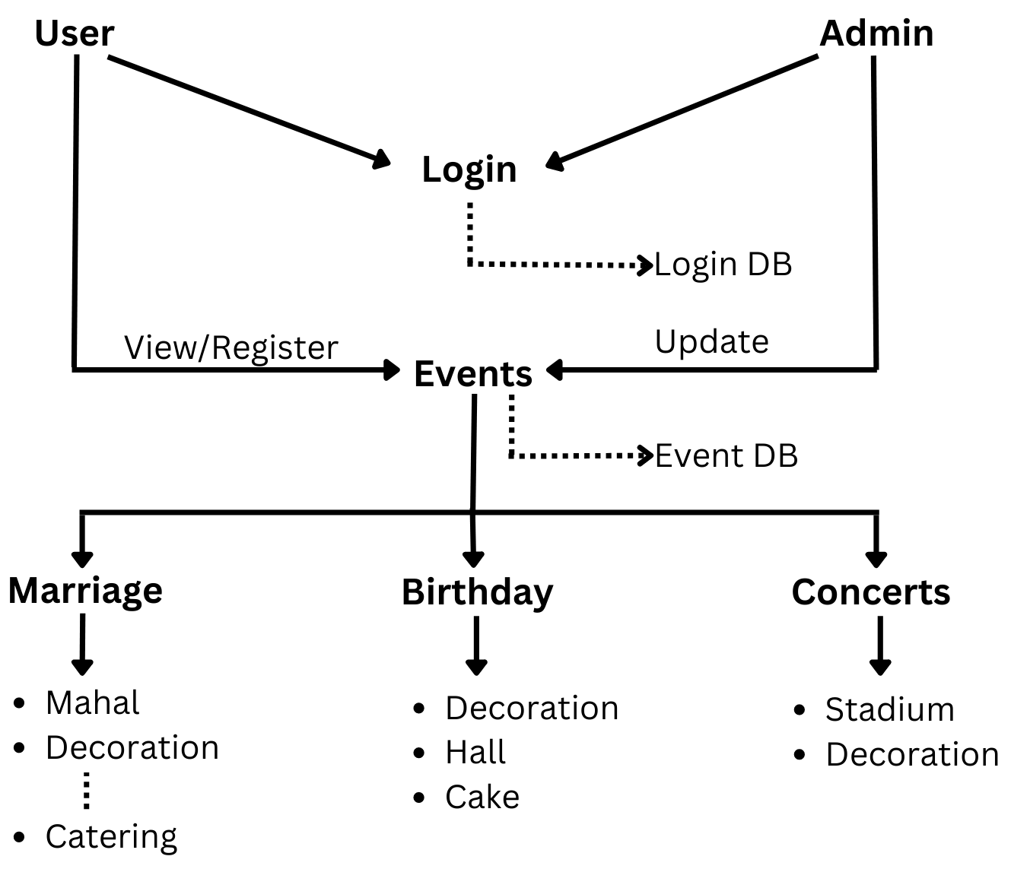
Fig 1 : Platform Description

3) Marriage Hall: Dedicate a page to showcase the available marriage halls or venues. Include high-quality images, detailed descriptions, and pertinent information about capacity, amenities, and location. Additionally, add a form or button for users to inquire about availability or directly book a particular venue.

4) Decorations: Create a page featuring diverse decoration themes or packages available for events. Utilize images and even videos to showcase the visual appeal of the decorations. Mention any customizable options and allow users to easily select their preferences or submit a decoration request.

5) Catering: Present a dedicated page displaying various catering packages, menu options, and cuisines available for events. Enhance user interest with enticing images of the dishes. Offer flexibility for users to choose their preferred catering package or request a customized menu tailored to their requirements.

6) Beauty salon: Design a captivating page that showcases the array of beauty and grooming services available in the Beauty salon, including makeup, hairstyling, and other treatments. Provide a seamless booking system allowing users to conveniently schedule appointments with the Beauty salon for their event day.

7) Cars: Devote a page to exhibit a range of transportation options available during events, such as luxury cars, vintage cars, or limousines. Offer a user-friendly booking feature that enables users to reserve their desired cars for the event day.

8) Contact and Inquiry Form: Incorporate a contact page or section containing essential contact information, such as phone numbers, email addresses, and physical addresses. Facilitate communication by adding an inquiry form where users can submit specific queries or request custom event packages.

9) User Testimonials and Reviews: Consider integrating a section dedicated to user testimonials and reviews from past clients. Positive feedback will foster trust and credibility for your event management service.

10) Responsive Design: Ensure that your website or app exhibits a responsive design, seamlessly adapting to various devices like desktops, tablets, and smartphones.

11) Visuals and Graphics: Enhance the overall user experience by using high-quality images and graphics throughout the website, captivating visitors with appealing visuals.

12) Security and Privacy: If your website intends to collect personal data or process payments, prioritize the implementation of appropriate security and privacy measures, such as SSL certificates and secure payment gateways. Always prioritize user experience and ease of navigation to provide an immersive experience, enabling users to visualize their dream event and make informed decisions.

- Target Customer

Event Organizers, whether they are individuals, companies, or organizations, are responsible for hosting a wide array of events, including conferences, workshops, concerts, weddings, fundraisers, and more. The platform assists them in
effectively managing and promoting their events, handling ticketing processes, and collecting valuable insights through analytics. [3,4,7]

Event Attendees can leverage the platform to explore and sign up for events that align with their interests and preferences. Additionally, they have the option to receive event reminders and updates, enhancing their overall event experience.

The platform offers significant advantages to event management agencies, allowing them to streamline event planning and execution, handle multiple events concurrently, and enhance collaboration with clients and vendors.

Businesses and corporations planning internal events, training sessions, team-building activities, or industry conferences can make use of the platform to elevate their event planning and ensure seamless execution.

- Commercial Impact

1) Competitive Advantage for Business: Companies that adopt MERN stack-based event management solutions can offer more efficient and feature-rich services to their clients. This provides a competitive edge in a market where organizers are constantly seeking innovative and streamlined ways to manage events.

2) Increased Efficiency and Productivity: Event management businesses can streamline their operations by leveraging the MERN stack. This leads to improved efficiency in tasks like event creation, attendee registration, communication, and data management. Consequently, businesses can handle more events with the same resources, enhancing their overall productivity.

3) Adoption of Innovation Features: MERN stack's capabilities, such as real-time communication and dynamic interfaces, allow for the development of innovative features within event management systems. Businesses that offer unique and engaging features can attract more clients and stand out in a competitive market.

4) Market Growth and Demand: As more businesses adopt MERN stack-based solutions, the market for event management tools is likely to grow. The increased adoption of digital event solutions is expected to drive demand for sophisticated platforms that offer real-time communication, data analytics, and user-friendly interfaces.

5) Customization and Flexibility: The flexibility of the MERN stack allows businesses to create highly customizable event management systems. This enables them to cater to a diverse range of events, from corporate conferences to music festivals, meeting specific requirements and enhancing their market reach.

6) Global Reach: Online event management solutions built using the MERN stack can be accessed globally. This opens up opportunities for businesses to serve clients from different countries and regions, expanding their market reach beyond their immediate geographical location.

7) Small and Medium Enterprises: MERN stack's modular approach and scalability make it suitable for SMEs that may have limited resources for event management. Affordable and scalable solutions can enable smaller businesses to enter the event management market and compete effectively.

8) Partnership and collaborations: Businesses that offer MERN stack-based event management solutions might form partnerships with technology providers, marketing agencies, and event venues. This collaboration can lead to a broader range of services being offered to clients, enhancing the overall value proposition.

9) Technological Innovation Driving Adoption: The technological innovation demonstrated by MERN stack applications can drive more event management businesses to adopt these solutions. As the demand for modern, tech-savvy event experiences increases, businesses must adapt to remain relevant.

10) Industry Standardization: The adoption of MERN stack-based solutions can contribute to establishing a new standard for event management systems. This standardization can help both businesses and clients have a common framework and understanding of what to expect from event management technology.

- further steps

We are excited to announce the next phase of our platform's development, which includes an improved dealer registration process. Dealers can now effortlessly join our network by creating personalized login IDs and passwords, ensuring a seamless and secure experience. This new feature empowers them to fully leverage our platform's capabilities to showcase their expertise in the wedding industry.

Once registered successfully, dealers can begin adding their offerings, starting with captivating marriage mahallas and delectable catering services. They have the freedom to provide detailed information about their menus and decorations, enabling potential clients to explore a wide array of options.

But we do not stop there! We encourage dealers to exhibit their creativity and artistry by uploading alluring images of their previous work. Whether it is beautifully designed wedding setups, mouthwatering cuisines, or stunning decorations, our platform transforms into a visual delight, inspiring soon-to-be-married couples.

As we endeavor to become the ultimate wedding planning hub, we have expanded our platform to include photography services and beauty salon. Dealers specializing in photography can now share their portfolios, offering couples a glimpse of the magic they can capture on their special day.

Similarly, beauty salon can showcase their exquisite services and facilities, accompanied by images that showcase the pampering and luxury they offer. With this comprehensive range of wedding services, our platform strives to become the go-to resource for engaged couples seeking the finest vendors to bring their dream weddings to life.

- Conclusion

To summarize, utilizing the MERN (MongoDB, Express.js, React.js, Node.js) stack for event management and organization offers a wide range of benefits for both event organizers and attendees. The MERN stack provides a strong and scalable foundation, facilitating streamlined event planning, flawless execution, and improved collaboration among organizers, clients, and vendors.

With its user-friendly interface and personalized features, the platform successfully draws in more attendees, leading to increased ticket sales and revenue for event organizers. Additionally, its potential for data monetization empowers businesses with valuable consumer insights and facilitates data-driven decision-making.

As the platform gains popularity and reaches a broader market, it becomes an appealing choice for potential sponsors and partners, thus creating additional revenue streams. Overall, the MERN stack proves to be an efficient and powerful solution for enhancing event management and ensuring exceptional event experiences.

References

- K. K. Logesh and M, "Mean stack web development", International Research Journal of Engineering and Technology (IRJET), vol. 7, 2020.
- Raju, Saravanan, S. Soundrarajan and V. Loganathan. “Mern stack web application”. Annals of the Romanian Society for Cell Biology 25, no.6 (2021): 6325-6332
- C. H. P. Y. P. Wibisono and A. Kesuma, ": e-vent: Support system for eventregistration", 2nd International Conference on Applied Information Tech-nology and Innovation (ICAITI), pp. 157-162, 2019.
- S. Madisetty, "Event recommendation using social media", 2019 IEEE 35th Inter-national Conference on Data Engineering (ICDE), pp. 2106-2110, 2019.
- G. L. Scoccia, P. Migliarini and M. Autili, "Challenges in Developing Desktop Web Apps: a Study of Stack Overflow and GitHub", 2021 IEEE/ACM 18th International Conference on Mining Software Repositories (MSR), pp. 271-282, 2021.
- Shukla, Santosh Kumar, Shivam Dubey, Tarun Rastogi, and Nikita Srivastava. "Application using MERN Stack." (2022).
- ] Allen, Johnny, Robert Harris, Leo Jago, Andrew Tantrai, Paul Jonson, and Eamon D'Arcy. Festival and special event management. John Wiley & Sons, 2022.
- Imran, Mohammed, Manoj Bhat, Yash Pal, Rakshith Reddy, and H. V. Abijith. "PeerConnect: Live Virtual Event Platform by using Web Server." In 2022 7th International Conference on Communication and Electronics Systems (ICCES), pp. 1663-1666. IEEE, 2022.
- Mehra, Monika, Manish Kumar, Anjali Maurya, and Charu Sharma. "Mern stack web development." Annals of the Romanian Society for Cell Biology 25, no. 6 (2021): 11756-11761.
- Heng, Javon Yi Jun. "Smart event organizer: one stop management system for all events using the MERN stack." (2020).
- Le, Hoang Khanh Ngoc. "Web Application for Searching Local Events." (2023).
- ] Murad, S. A., Murad, D. F., Wandanaya, A. B., & Fernando, E. “Critical Success Factor Online Service Quality in Online Marketing: A Systematic Literature Review.” International Conference on Information Technology and Electrical Engineering, 2018.
- Pinhanez, C. “A Services Theory Approach to Online Service Applications.” IEEE International Conference on Services Computing, 2018.
- Kumar, G. S., & Jose, J. T. “Developing an electronic commerce platform.” IEEE International Conference on Power, Control, Signals, and Instrumentation Engineering (ICPCSI), 2017.
- Wangmo, J., Tenzin, S., Lhamo, T., & Dorji, T. “Report on the Feasibility Study of E-Commerce Website Development for the Cooperative Store at College of Science and Technology.” International Conference on Current Trends Towards Converging Technologies, 2018.

